Engaging | Supportive | Award-Winning
VIRTUAL LEARNING
FOR STUDENTS GRADES K–5
Featuring EdOptions Academy and Calvert Learning

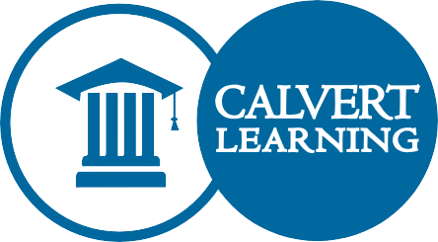
Online courses with personal, real-world support
Did you know that our school partners with EdOptions Academy and Calvert Learning to offer high-quality, personalized online instruction, paired with state-certified elementary educators, that is specifically created for K–5 students?
If your child is struggling in the traditional classroom, learning at a different pace than his or her classmates, or if your family schedule requires more flexibility, our program featuring EdOptions Academy online courses may be the right fit.

A quality learning experience proven to engage young learners
EdOptions Academy is a leader in high-quality virtual learning. Their courses:
- Feature carefully curated, research-based lessons designed for elementary learners
- Include problem-based activities and projects that encourage and challenge students to apply what they learn in deeper, more meaningful ways
- Keep students engaged with interactive multimedia resources, including skill-building games, videos, quizzes, and virtual labs
- Support families who want to be involved in their child’s daily learning experience

What you can expect
EdOptions Academy online elementary courses powered by Calvert Learning are designed to give students a truly personalized learning experience. When you enroll your student in our virtual K–5 program, you and your child will:
  - Have access to courses 24/7 from any computer or mobile device connected to the Internet; many courses are optimized for mobile devices, including tablets
  - Be able to work closely with a state-certified EdOptions Academy online teacher, with regular communication via video conferencing, phone, and email; families will play a hands-on role in facilitating collaborative instruction
  - Be exposed to engaging activities designed to meet the needs of young learners, including videos, audio content, and problem-based interactive lessons
  - Have access to helpful teaching notes to facilitate daily lessons and progress and pacing monitoring tools to help you stay on track
  - Be able to continue as part of our school community with access to extracurriculars and additional school-provided supports
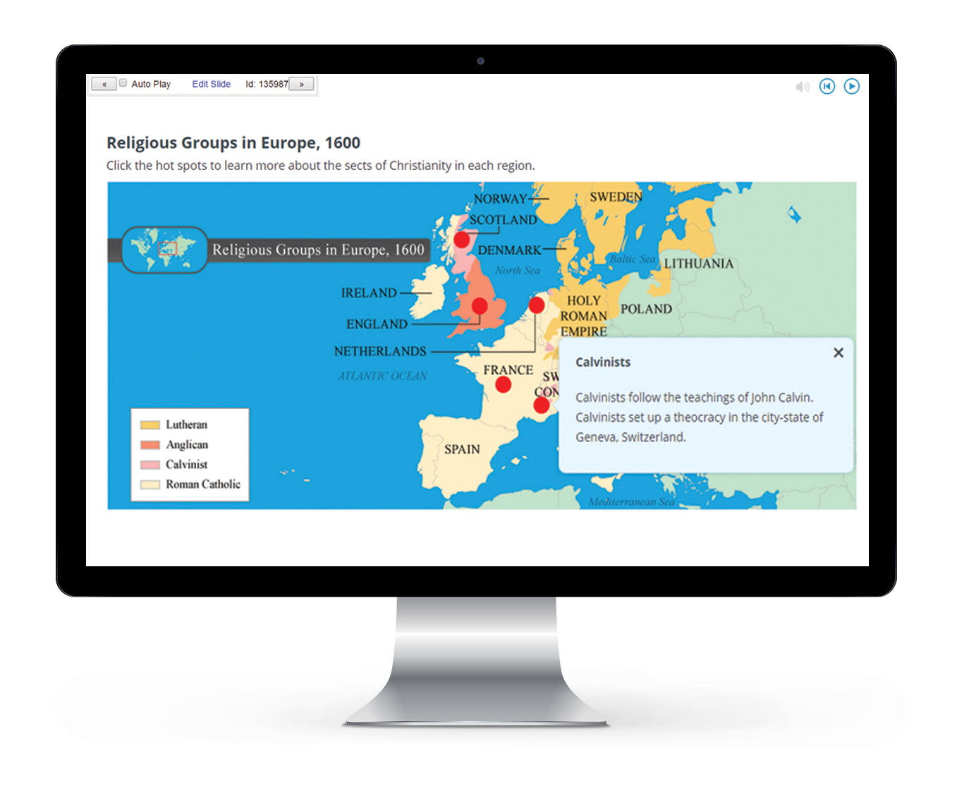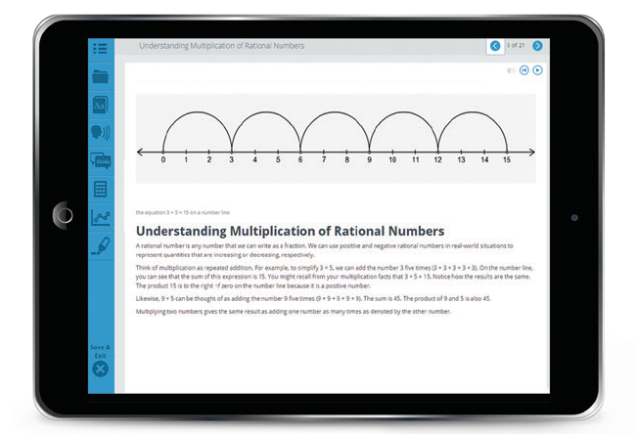

Ready to get started?

Call:
Enter Contact Here

Or Visit:
Add URL Here

edmentum.com AC033-40-1 073019
Partnering with you and your child for success
5600 W 83rd Street Suite 300, 8200 Tower
Bloomington, MN 55437
© 2019 EDMENTUM, INC.

