Engaging | Supportive | Award-Winning
Online Learning Option for Middle and High School Students
Featuring Engaging Courses and Support from Edmentum’s EdOptions Academy

An engaging learning experience created for a variety of students
Did you know that our school partners with EdOptions Academy to offer rigorous, engaging online courses in high-demand subjects? If your child prefers a nontraditional learning environment, requires a more flexible schedule, learns at a different pace than his or her peers, or wants to catch up or get ahead in his or her studies, EdOptions Academy’s online courses may be the right fit for your family.

Online courses with real-world support
EdOptions Academy is a leader in high-quality virtual learning. The online courses:
- Are fully accredited by AdvancEd and help your child work toward his or her high school diploma.
- Are approved by the NCAA® to support college-bound student athletes.
- Are part of a library of 400+ options, including core, elective, world language, career and technical education, and advanced courses.
- Pair engaging, research-based online courses with highly qualified, state-certified virtual teachers.

What you can expect
EdOptions Academy’s online courses are designed to give your child a truly personalized learning experience. When you enroll your child in our program, you and your child will:
- Be able to access course(s) 24/7, from any computer connected to the Internet; many courses are optimized for mobile devices, including tablets
- Be able to work closely with state-certified EdOptions Academy online teachers, with regular communication via video conferencing, phone, and email; many teachers also offer live lessons and virtual “office hours” for real-time instruction and extra help
- Be exposed to engaging activities designed to meet the needs of diverse learners, including videos, audio content, and problem-based interactive lessons
- Have access to pacing and progress-monitoring tools to help stay on track
- Continue to be part of your local school community with access to extracurriculars and school- provided supports
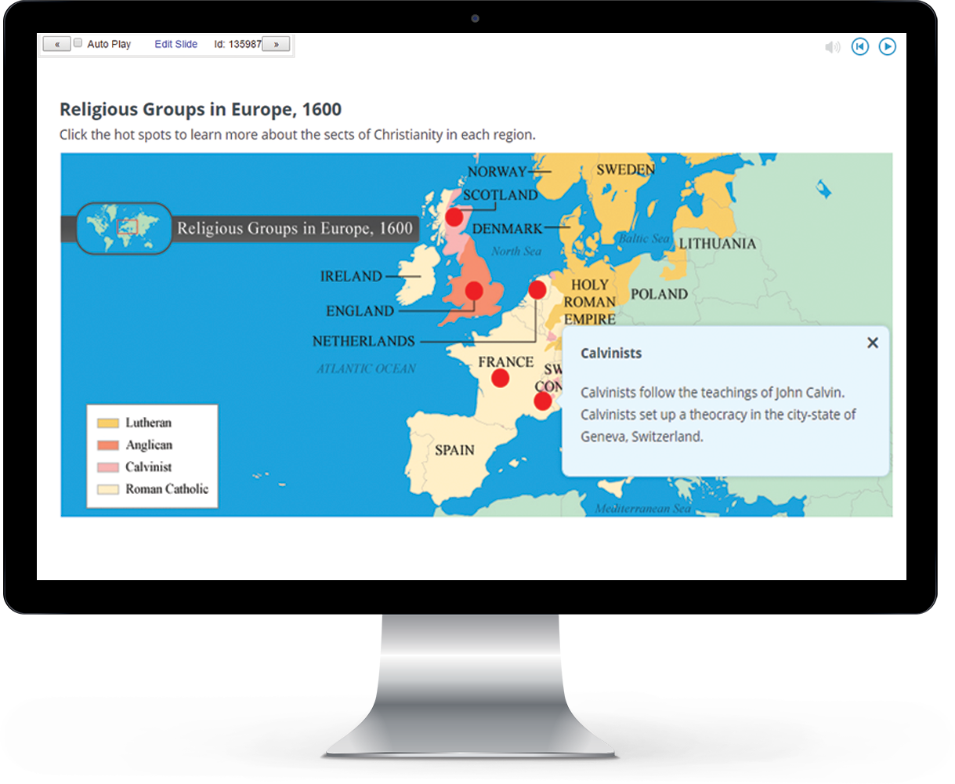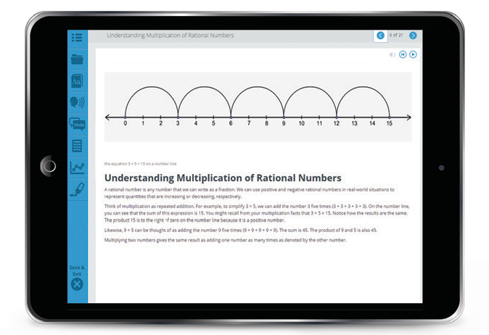

Ready to get started?

Call: Visit:
Enter Contact Here Add URL Here

edmentum.com 800.447.5286
Partnering with you and your child for success
info@edmentum.com AC033-41-1 123020
5600 W 83rd Street Suite 300, 8200 Tower
Bloomington, MN 55437
© 2019 EDMENTUM, INC.

