PNG Logo Download

Edmentum - Short Description
This content can be used on your website or anywhere to describe Edmentum in general or EdOptions Academy curriculum.

With 60 years of experience, Edmentum empowers educators to transform their approach and build school around the needs of each child. Edmentum partners closely with more than 8,000 school districts, schools, and their teachers to provide courses and online learning tools that open up a world of opportunity for students.

Calvert Learning K-5 Courses - Short Description
This content can be used when describing Calvert Learning elementary courses.

Calvert Learning’s step-by-step lessons build creative problem-solving and critical thinking skills. Trusted for over a century, Calvert is known for its academic rigor and engaging approach that motivates young students and creates a love of learning.

The Calvert Learning curriculum offers students and their families:
- An easy-to-use online platform that brings lessons to life with multimedia
- Project-based learning activities that build creative thinking and problem-solving skills
- Teaching tips and resources designed to help parents guide young learners learning from home
- Best-in-class learning resources that engage young learners and encourage active learning

Edmentum Courseware 6–12 Courses - Short Description
This content can be used when describing Edmentum Courseware courses for grades 6-12.
Whether students are on grade level, falling behind, or advanced, Edmentum courses are designed to engage students, meet them where they are, and help guide them to reach their full potential.

Edmentum Courseware 6–12 courses provide students with:
- A foundation for college and career readiness
- A rigorous, engaging learning experience
- 400+ semesters of award-winning core, elective, world language, and advanced course options

Edmentum Courseware Awards
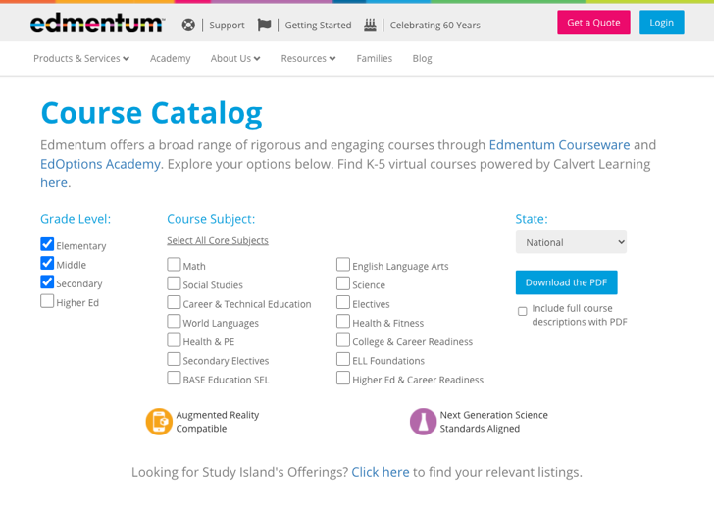
Marketing Tip:
Students and families are often interested in knowing what courses are offered and seeing course descriptions for an idea of what will be covered. Use the checkbox options on the course catalog page of the Edmentum website to create a catalog link to post on your site for your families to browse.

