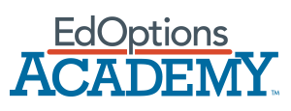
JPG Logo Download

EdOptions Academy – K-12 courses plus EdOptions Academy teacher support
Why EdOptions Academy?
Include these points when explaining the main benefits of EdOptions Academy. Add your program’s additional differentiators to help set your school apart.

Main differentiators:
- Certified teachers trained in online instruction
- Personalized, ongoing support from teachers via video conferencing, phone, email, or text
- 400+ semesters of award-winning, engaging courses
- A flexible learning experience suited to a variety of learners
- Accreditation by Cognia™
- NCAA®-approved courses to support college-bound student-athletes
Additional differentiators depending on your school’s offering:
- 24/7 live tutor support

EdOptions Academy Accreditation and Awards Logos

Extended descriptions of differentiators:
Highly-qualified, state-certified teachers: Students are taught by certified teachers who are trained to support students in an online learning environment, provide continuous progress monitoring, and personalize student learning.
Ongoing support: Our instructors are committed to building strong relationships with both students and parents. Regular communication occurs via video conferencing, phone, and email; teachers also offer live lessons and virtual “office hours” for real-time instruction and extra assistance to help students understand course material and stay on track to achieve their academic goals.
400+ engaging, award-winning courses: Choose from Edmentum’s catalog of over 400 media-rich courses, including core, world language, elective, career and technical education, and advanced courses.
Flexible, personalized learning experience: [School name] provides students with the flexibility to access and complete coursework when and where it’s most convenient for them at a pace that works for them. Courses are also designed to meet the needs of all learners with media-rich content, activities, and learning tools.
Accreditation and approvals: [School name] adheres to high-quality standards based on the latest research and successful professional practices. Our online program is accredited by Cognia™/AdvancED®. This accreditation provides us the unique ability to offer high school credits and diplomas recognized by schools and colleges across the U.S. and around the world.

EdOptions Academy Teachers
EdOptions Academy’s highly qualified teachers are a huge differentiator when speaking to the benefits of virtual learning. Be sure to consistently focus on this message and leverage some of the talking points below in outreach.
Marketing Tip:
Spotlight EdOptions Academy by highlighting a day in the life in your communications:
Day in the Life of an EdOptions Academy Teacher VIDEO
Highly qualified, U.S.-certified online teachers experienced in online instruction connect learning to real-life experiences. Academy teachers:
- Provide newly enrolled students with an overview of help resources
- Respond to student needs via phone calls, text messages, emails, and other forms of communications to provide direct instruction and any additional clarification
- Respond to all emails, messages, and text messages from students, parents, and site coordinators
- Grade student work and provide feedback and encouragement
- Monitor students’ progress and success and make recommendations concerning student pace, progress, performance, and remediation as needed
- Contact students who haven’t logged into the program recently (typically five to seven days or more)

Calvert Learning K-5 Courses - Short Description
This content can be used when describing Calvert Learning elementary courses.

Calvert Learning’s step-by-step lessons build creative problem-solving and critical thinking skills. Trusted for over a century, Calvert is known for its academic rigor and engaging approach that motivates young students and creates a love of learning.

The Calvert Learning curriculum offers students and their families:
- An easy-to-use online platform that brings lessons to life with multimedia
- Project-based learning activities that build creative thinking and problem-solving skills
- Teaching tips and resources designed to help parents guide young learners learning from home
- Best-in-class learning resources that engage young learners and encourage active learning

Edmentum Courseware 6–12 Courses - Short Description
This content can be used when describing Edmentum Courseware courses for grades 6-12.
Whether students are on grade level, falling behind, or advanced, Edmentum courses are designed to engage students, meet them where they are, and help guide them to reach their full potential.

Edmentum Courseware 6–12 courses provide students with:
- A foundation for college and career readiness
- A rigorous, engaging learning experience
- 400+ semesters of award-winning core, elective, world language, and advanced course options

Edmentum Courseware Awards
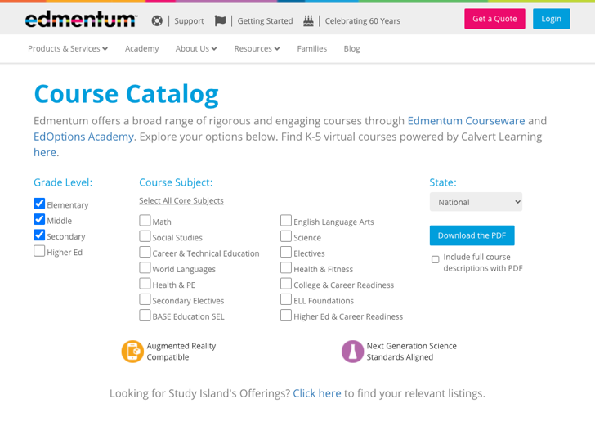
Marketing Tip:
Students and families are often interested in knowing what courses are offered and seeing course descriptions for an idea of what will be covered. Use the checkbox options on the course catalog page of the Edmentum website to create a catalog link to post on your site for your families to browse.

Benefits of Virtual Learning
Sharing the benefits of virtual learning and who your program serves helps ground your audience in how or why a virtual school environment could fill their needs. These benefits and student groups can also help guide your content creation.

Virtual learning provides a variety of students with the flexibility meet their educational goals when and where they learn best. This often provides students with the opportunity to participate in out-of-school activities that they would not be able to engage in if confined to a traditional school day. Students are never alone in their learning journey and are supported by instructors who interact with students both synchronously and asynchronously through live lessons, collaborative group activities, live help hours, phone calls, emails, and text messages. Teachers also review student work and progress and provide detailed feedback and guidance for a successful learning experience.

Virtual learning supports:
- Homeschool students
- Students in military families or whose families travel often
- Hospitalized or homebound students
- At-risk students or students who need credits to graduate
- Students with emotional or behavioral needs
- Advanced students (gifted, 2E students)
- Competitive athletes or performers
- Students with scheduling conflicts because of work or family obligations

